**Objective:-** Backend: Using NodeJS, build a real time chat application or email sender.

**Code :-**

**index.js**

const express = require('express');

const app = express();

const http = require('http');

const server = http.createServer(app);

const { Server } = require("socket.io");

const io = new Server(server);

app.get('/', (req, res) => {

  res.sendFile(__dirname + '/index.html');

});

io.on('connection', (socket) => {

  socket.on('chat message', (msg) => {

    console.log('message: ' + msg);

    io.emit('chat message', msg);

  });

});

server.listen(3000, () => {

  console.log('listening on *:3000');

});

**index.html**

<!DOCTYPE html>

<html lang="en">

<meta name="viewport" content="width=device-width, initial-scale=1">

<html>

  <head>

    <meta charset="utf-8">

    <title>Socket.IO chat</title>

    <style>

      body { margin: 0; padding-bottom: 3rem; font-family: -apple-system, BlinkMacSystemFont, "Segoe UI", Roboto, Helvetica, Arial, sans-serif; }

      #form {

        background: rgba(0, 0, 0, 0.15);

        padding: 0.25rem;

        position: fixed;

        bottom: 0;

        left: 0;

        right: 0;

        display: flex;

        height: 3rem;

        box-sizing: border-box;

        -webkit-backdrop-filter: blur(10px);

        backdrop-filter: blur(10px);

      }

      #input { border: none; padding: 0 1rem; flex-grow: 1; border-radius: 2rem; margin: 0.25rem; }

      #input:focus { outline: none; }

      #form > button { background: #333; border: none; padding: 0 1rem; margin: 0.25rem; border-radius: 3px; outline: none; color: #fff; }

      #messages { list-style-type: none; margin: 0; padding: 0; }

      #messages > li { padding: 0.5rem 1rem; }

      #messages > li:nth-child(odd) { background: #efefef; }

    </style>

  </head>

  <body>

    <ul id="messages"></ul>

    <form id="form" action="">

      <input id="input" autocomplete="off" placeholder="Type your message..." type="text" /><button type="submit">Send</button>

    </form>

    <script src="/socket.io/socket.io.js"></script>

    <script>

      var socket = io();

      var messages = document.getElementById('messages');

      var form = document.getElementById('form');

      var input = document.getElementById('input');

      form.addEventListener('submit', function(e) {

        e.preventDefault();

        if (input.value) {

          socket.emit('chat message', input.value);

          input.value = '';

        }

      });

      socket.on('chat message', function(msg) {

        var item = document.createElement('li');

        item.textContent = msg;

        messages.appendChild(item);

        window.scrollTo(0, document.body.scrollHeight);

      });

    </script>

  </body>

</html>

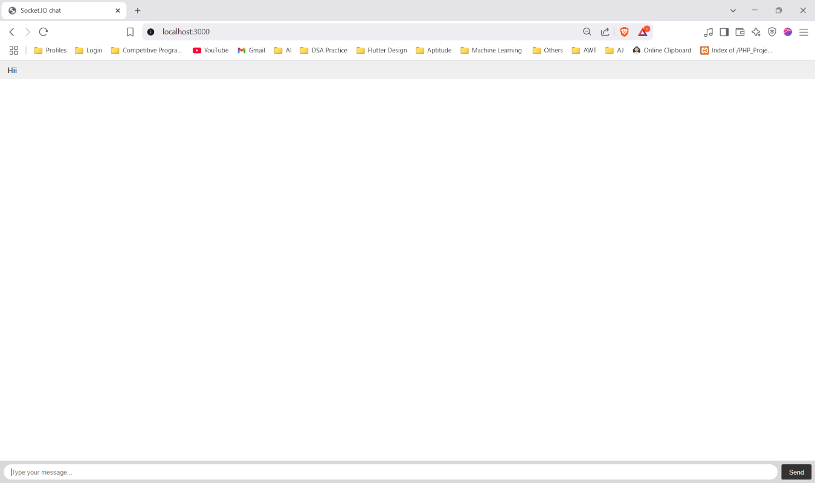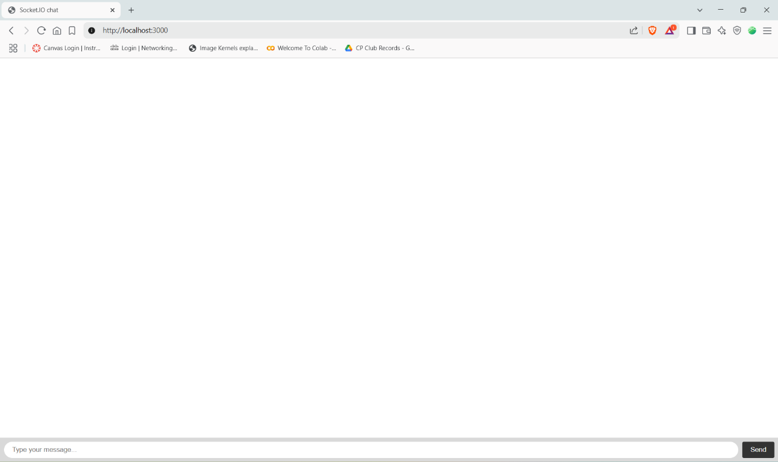**Output :-**

